**Working with RDS**

Create an RDS Database Instance

SS1: Db instance page

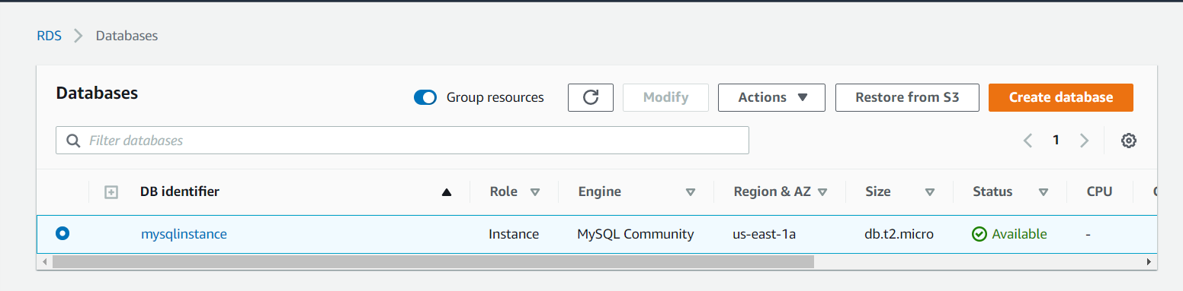

SS2: DB instance details

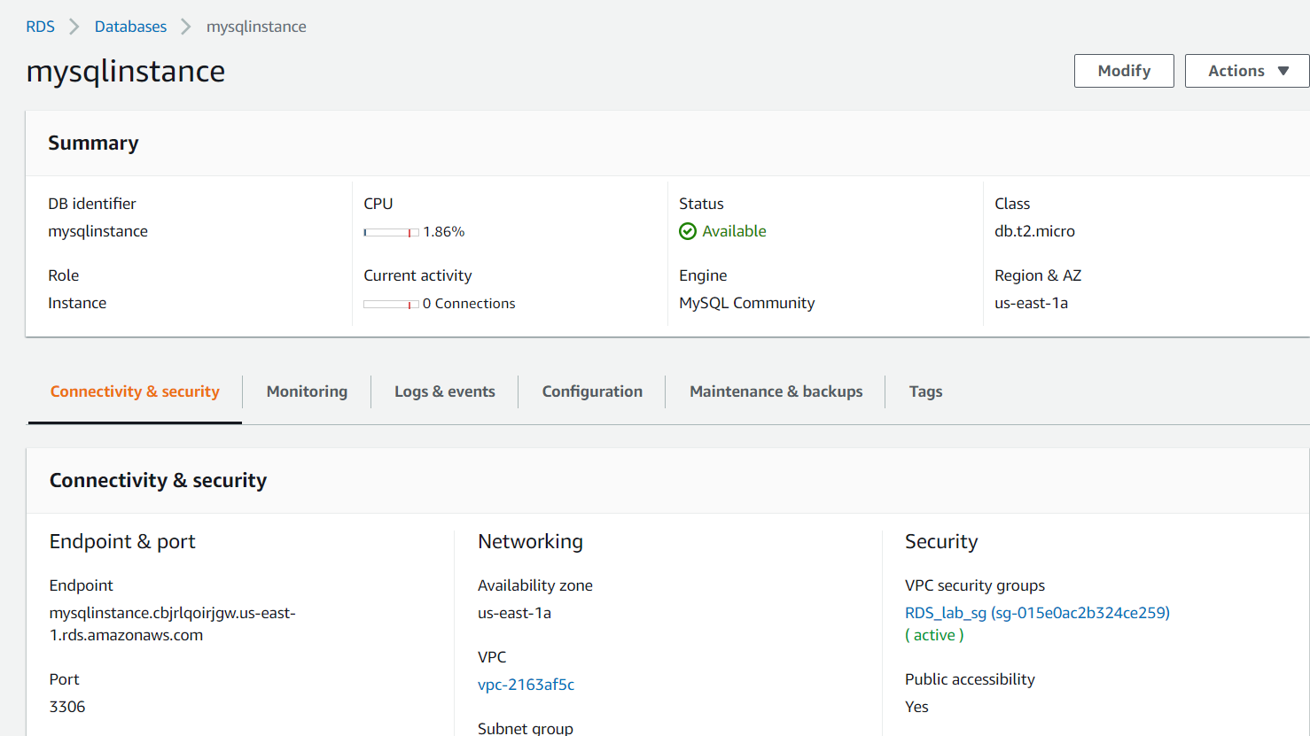

SS3: security group inbound rules

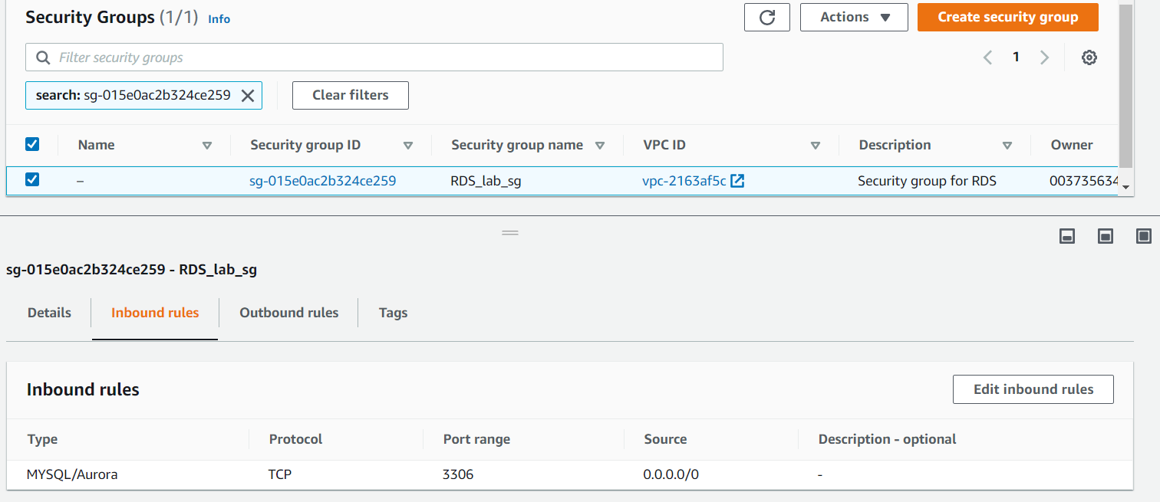

SS4: connecting to RDS instance

